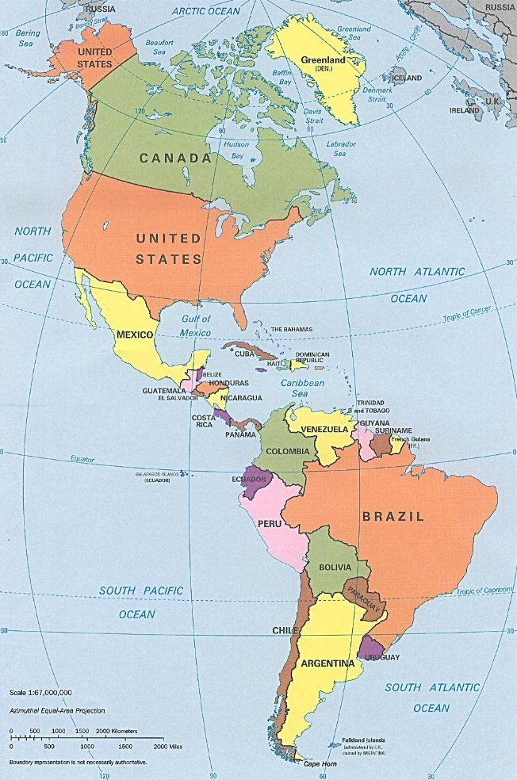
Welcome to 5th grade Social Studies!
This year, we will learn about the Western Hemisphere: North America, Central America, and South America.
The major topics we will focus on include:
* Geography, including landforms and political boundaries
* Complex Societies and Civilizations, including the Maya, Incas, and Aztecs
* Early Peoples of the Americas, including Native American groups across the continents
* European Exploration and its Effects on both the land and the indigenous people already living there
* Government, including its structure, important historical documents and events, and the fight for civil/human rights
* Comparative Cultures, including those of Canada and Mexico
* Economics, and how countries work to earn/make money as well as trade with other nations

We will be using a variety of sources to learn historical information, think critically, and discuss important topics in a constructive and respectful manner. We will also have the ability to use that information to answer questions and construct short and extended written responses, as well as create a few fun projects centered around what we are studying.

